**Manual**

Component

1. STR_1.5U_Base 1 Piece

1. STR_1.5U_Top 1 Piece

1. STR_1.5U_Side-Frame 4 Pieces

1. Payload IOT00X 1 Piece

1. Subsystem EPS10200X 1 Piece

1. Subsystem COM10200X 1 Piece

1. Subsystem MTQ 1 Piece

1. Subsystem MTQ Sensor 1 Piece

1. Subsystem Antenna_Deployment

1. External_Port_Panel 1 Piece

1. Solar_Panel X-Minus 1 Piece

1. Solar_Panel Y-Plus 1 Piece

1. Solar_Panel Y- Minus 1 Piece

1. Solar_Panel Z- Minus 1 Piece

1. Spacer Axis 4 Pieces

1. Spacer 4 mm. 4 Pieces

1. Spacer 10 mm. 4 Pieces

1. Spacer A-D 1 set mm.
2. Ultra Low Head Cap Screws M2.5x3 16 Pieces

1. Ultra-Low Head Hexalobular Socket Head M2.5x5 28 Pieces

**Assembly Procedure for External Panel**

1. Connect Raspbessy Pi Camera with Camera Jig

* Use 4 x CSPPN1P-BRN-M1.6-8 and 4 x HNT1EB-BR-M1.6

1. Connect the camera with jig and solar panel

* Use 4 x SSTS-M3-8 with 4 x SLBNR3 and tighten them

1. Place the GPS module on the solar panel

* Put the epoxy at the corner of GPS module in order to secure the location of module on solar panel

**Satellite Assembly Procedure**

1. Put 4 spacers axis into holes on STR_1.5U_Base. We will define each spacer axis position by following picture.

1. Place EPS10200X on STR_1.5U_Base

1. Place MTQ on EPS10200X

1. Place 4 Spacers 10 mm and 4 mm on MTQ

1. Place COM10200X on spacer 14 mm

1. Place IOT00X on COM10200X

1. Place MTQ Sensor on IOT00X

1. Place Spacer set A-D on MTQ Sensor by match set and Spacer Axis Posiotion

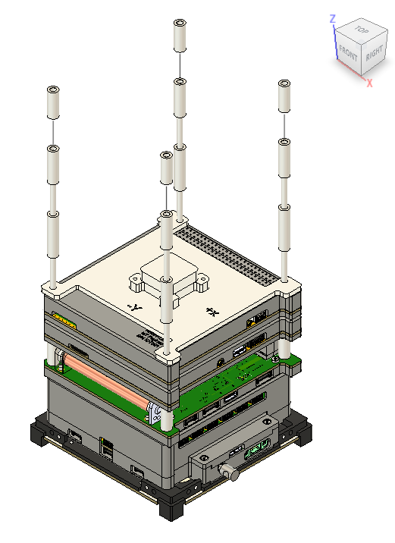

1. Place 4 STR_1.5U_Side-Frame to STR_1.5U_Base

1. Tighten 4 of STR_1.5U_Side-Frame and STR_1.5U_Base with 8 of Ultra Low Head Cap Screws M2.5x3

1. Place STR_1.5U_Top on Spacer Axis

1. Tighten 4 of STR_1.5U_Side-Frame and STR_1.5U_Top with 8 of Ultra Low Head Cap Screws M2.5x3

1. Remove 4 of M2x6 bolts on Antenna_Deployment Cover

A black rectangular object with a black square object with a black square object with a black square object with a black square object with a black square object with a black square object with a black square object

1. Remove Antenna_Deployment Cover

1. Tighten 8 of M2.5x8 bolts from Antenna_Deployment to STR_1.5U_Top

1. Close Antenna_Deployment Cover

1. Tighten 4 of M2x6 bolt on Antenna_Deployment Cover

1. Put RBF into EPS10200X

1. Connect all wires following Electrical Interface Document
2. Flip Satallite
3. Attch a wire between Solar_Panel Z-Minus and EPS10200X module
4. Tighten 4 of Ultra-Low Head Hexalobular Socket Head M2.5 bolts to Solar_Panel Z-Minus

1. Flip Satallite
2. Remove RBF

1. Attach a wire between External_Port_Panel and EPS10200X module
2. Tighten 6 Ultra-Low Head Hexalobular Socket Head M2.5 bolts to External_Port_Panel

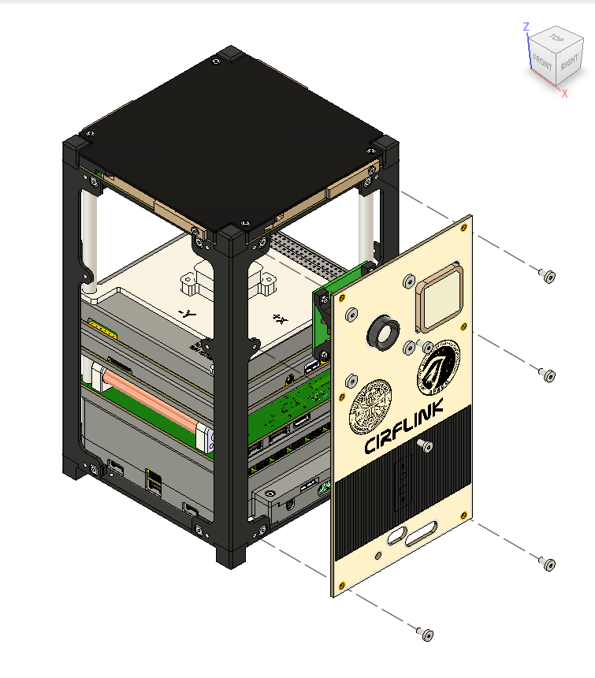

1. Put RBF into Satellite

1. Attach a wire between Solar_Panel Y-Plus and EPS10200X module
2. Tighten 6 Ultra-Low Head Hexalobular Socket Head M2.5 bolts to Solar_Panel Y-Plus

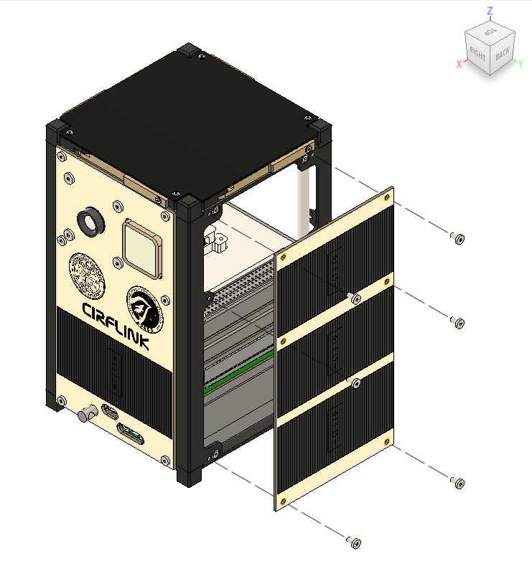

1. Attach a wire between Solar_Panel Y- Minus and EPS10200X module
2. Tighten 6 Ultra-Low Head Hexalobular Socket Head M2.5 to bolts Solar_Panel Y-Minus

1. Attach a wire between Solar_Panel X-Minus and EPS10200X module
2. Tighten 6 Ultra-Low Head Hexalobular Socket Head M2.5 to bolts Solar_Panel X-Minus

**Antenna Folding Procedure**

1. Bend the antenna and close the door

1. Fold the antenna completely as a picture below

1. Take a thumb screw (M2x8) and tighten it

1. Repeat the procedure No.1, 2, and 3.

* The final results shall be the same as picture.